THREATENED BATS THREATEN DAMAGING A350 BYPASS AND HOUSING AT YARNBROOK!
Email report of Pat Kinnersly, adapted by Andrew Nicolson, WCA. 19-30 Nov 2020
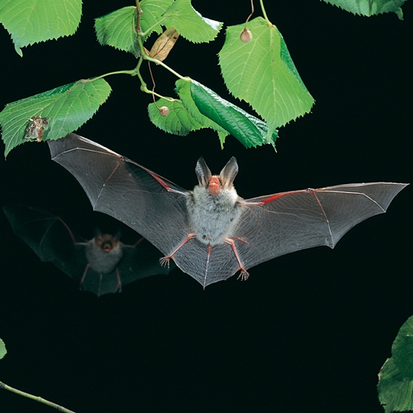
Paddy Bradley, CEO OF the Swindon and Wiltshire Local Economic Partnership (SWLEP) has confirmed informally that the funding for the A350 Yarnbrook-West Ashton Relief Road has been withdrawn because work could not start on site before a funding deadline of March 2021. The road, with its linked housing developments, threatens the wellbeing of ancient and other woodland at Biss Wood, Clanger Wood and Green Lane Wood. These are home to endangered wildlife including a precious and important colony of Bechstein's bat, which is protected under the European Habitats Directive. In the UK it is one of the region's rarest and most endangered species, where it likely that no more than 1,000 individuals exist in the whole region.

Bradley said the road was still expected to go ahead but not with SWLEP funding. The problem was caused by big housebuilder Persimmon Home PLC’s concerns over the financial viability of the site. Wiltshire Council had been negotiating with the firm for two years but the parties had not been able to reach an agreement. (The funding deal was to include £5.5 million of SWLEP funding from public money and £8M of Housing Infrastructure Fund (HIF) “Marginal Viability” funding from the government agency Homes England, a quango sponsored by the Ministry of Housing, Communities & Local Government.
He added that he hoped the road would be built because it was important for the strategic A350 corridor through Dorset to the South Coast ports. He mentioned the Melksham bypass as the LEP’s next priority scheme in the growth corridor. He was unable to confirm whether Wiltshire and Dorset intended to go ahead with the Shaftesbury eastern bypass, when asked by veteran Wiltshire transport campaigner Patrick Kinnersly.
Patrick is the secretary of the White Horse Alliance that in 2009 successfully forced the government to reject Wiltshire Council’s scheme for an A350 Westbury Eastern Bypass, which would have damaged the Wellhead Valley and its endangered wildlife, and harmed the landscape setting of the famous White Horse of Westbury, without delivering the full traffic and transport benefits claimed for it.
Patrick commented, “So it looks as if our strategy of holding up the construction of Ashton Park and its roads by insisting on the highest available standards for protecting endangered wildlife has paid off. For now. The planning application for Ashton Park and its en-suite section of the A350 strategic growth corridor (15/04736/OUT) was submitted in May 2015. Planning permission and start of construction were expected to follow soon afterwards and the road would be heading for completion by the end of 2018. In practice it wasn’t until the spring of 2018 that the application had been revised enough even for the uncritical members of a WC planning committee to nod it through. By then the road had been redesigned to raise the carriageway so that bat underpasses could be built beneath it. The layout of the estate had been revised to reduce the risk of disturbance to the rare Bechstein’s bats in ancient woodlands east of Trowbridge.”
Patrick and other South West transport and environment campaigners have been heavily critical of Wiltshire Council’s Bat Mitigation Strategy, and have doggedly pursued breaches and threats even to the point of a petition to the European Parliament.
Patrick has been a key player. To lay out the background, he continued, “Wiltshire Council has only itself to blame. It chose the site for a massive eastward extension to Trowbridge in order to get the developer to pay for what it hoped would be a new section of the A350. Persimmon agreed to contribute £11.5m. The LEP committed to another £5.5m.
“Natural England warned Wiltshire Council in 2009 that it might not be able to build a 2,500-home estate near these woods and not breach the European Habitats Directive. The White Horse Alliance commissioned the eminent bat ecologist Dr John Altringham to give expert evidence at the Examination in Public of the council’s Core Strategy (draft local plan) in 2013. He warned the council that building Ashton Park and its road could lead to the eventual extinction of the breeding colonies of Bechstein’s bats roosting in ancient woods next to the site.
“Wiltshire Council ignored the warnings and nodded the planning application through in 2015. it wasn’t until it hired an independent consultant to make sure the project would comply with the European Habitats Directive that it was forced to recognise that Professor Altringham had been right all along. The road had to be raised and housing moved away from the woods.
“Wiltshire had promised ratepayers that they would get a ‘free’ road; Persimmon would not cover the extra costs involved. The council turned to the government for a bailout. Homes England obligingly agreed to cough up another £8m, in the nick of time before the revised plan could be submitted to the council’s strategic planning committee in April 2018.
“Wiltshire Council must now find the funding to replace the lost £5m from the SWLEP. Clearly Persimmon will refuse to add any more costs to a development that is already overburdened with “Section106” commitments [Planning obligations under Section 106 of the Town and Country Planning Act 1990]. Will Homes England want to increase the £8m already staked on ‘unlocking housing growth’ east of Trowbridge?
“In the unlikely event that the council could assemble the money it cannot force Persimmon to build a huge urban extension burdened with the cost of roads, services, flood control, schools and communal facilities, Patrick concluded. “Demand for housing is depressed. When it revives buyers may no longer want to live in a badly-built box in a non-place of concrete and parked cars where the countryside used to be.
“Some of the rarest bats in Europe have just escaped the threat of extinction for another few years. This is a welcome reprieve!”
[ENDS]

