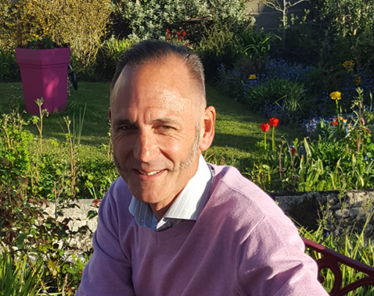

I’ve done a lot of stuff over the years, particularly on my current house where I’ve learned a lot, always focusing on how to achieve maximum functionality from minimum cost using the path of least resistance to getting it done.

“DIY has been my antidote to stressful hard work through my professional career as an electronics engineer. Starting aged 14, I’ve inhabited, stripped and renovated five old family homes 1680 to 1975; one listed, two thatched. I DIY everything except plastering & certification. I’ve always worked on one room a time with an average rate of one room per year. I’m happy to show&chat over a coffee about a range of household carbon reduction steps from £0(easy) to DIY(big) and share my experience of Professional installs.

Areas: Know and use the carbon cost of your electricity, insulate with ivy, fit programmable TRVs to radiators, refresh UPVC window/door seals, upgrade casement single- or double- glazing to A+++ DGUs, move to an induction hob, use recycled RIB insulation, retro-fit a rainwater harvesting system (the key component), use 6mm insulation& 18mm low profile panels for a 24mm retro-fit UFH system over cold concrete pad, fit a UFH Manifold & PERTpiping, use SFUF & insulated plasterboard for 35mm internal wall retro- insulation, fit a 90%Ƞ sealed woodburner, insulate a register plate, urban wind data (power estimates/issues), self-estimate your Solar PV potential & see shadowing, SolarPV installations (x4) with ZeroChippenham, ASHP or GSHP (calculated)? GSHP installation with ThermalEarth.”

Warm regards,
Adrian
ps Recover the slots used up by RCDs in your consumer unit by fitting a full set of RCBOs (for those new PV, EV, GSHP/ASHP & Immersion circuits).

Contact Adam on THIS LINK

